1.7. Updating Software
We constantly work on improving Streamline by adding new features and expanding its capabilities.asd
To check for updates, in the Menu bar click Help> select Check for updates…
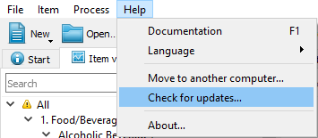
- If a new version is available, download the installation package of the latest version.
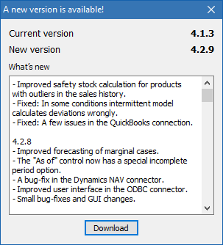
- If you are using the latest version, you’ll be informed with a message.
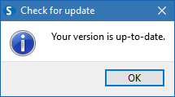

Next: How to Translate Streamline
Download PDF
Tracedump:
newBaseSize: 16pt
newBaseSizeInPt: 16

