5.8. New Product Forecasting
Streamline offers several methods to forecast a new product:

Top-down forecasting
This method implies that the item's forecast is calculated based on the parent item model and the market share that the item forms in its parent category.
To use this approach, select the new product in the Tree View, then in the Forecasting tab go to the Forecast approach control, select Top-down and click the Forecast button in the program toolbar.
The grey down arrow indicates that the top-down method has been applied to generate forecasts for the item.
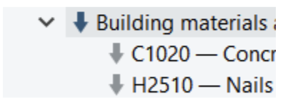

Applying the model of another product
Streamline allows borrowing a model from another item. To use this method, select an item in the Tree View, right-click on it, and select the Copy item to the clipboard. Then select the item to the model that will be applied, go to the Forecasting tab, and paste the copied item code in the Use model from control, click the Forecast button.
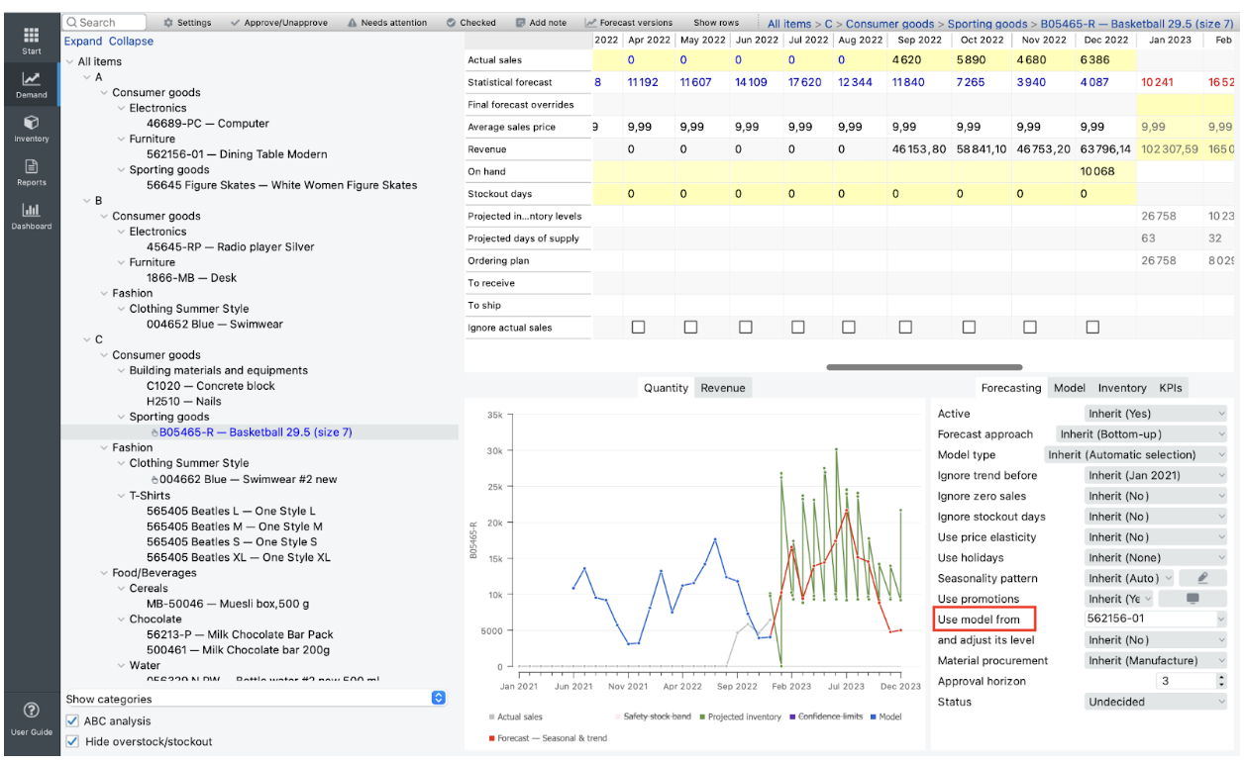
 | This method cannot be used for the same item code from different locations or if the source item code and the new one are from different channels

Applying the pattern of another product
One of the features of Streamline is the ability to detect and incorporate seasonal patterns in the data. For example, when working with a new product, you may not have enough historical sales data to build an accurate model. In this case, you can borrow a pattern from another product with similar demand and use it to forecast the new product.
To apply the seasonality pattern of another product, do the following:
- Choose the item whose pattern you want to use in the Tree view.
- Then, in the Panel tab ‘Model,’ click on ‘save as pattern.’
- Specify the seasonal pattern name and level in the Create seasonality pattern dialog.

Next: Product Substitutions
Download PDF
Tracedump:
newBaseSize: 16pt
newBaseSizeInPt: 16

