The table can have gaps or even empty rows. A gap occurs when there were no actual sales in the period. Streamline can’t calculate APE in this case. An empty row arises if either the item is inactive or an intermittent model is used.
The last two columns of the report represent MAPE and Weighted MAPE calculated across all of the periods for each planning item.
The Overall MAPE, shown in the toolbar, is MAPE weighted across all the items in the project. If the products’ prices are given this is a price-weighted MAPE measure that represents overall revenue percentage error. Otherwise, it is calculated based on the volume of sales. You can read more about WMAPE on Wikipedia.
You can also switch the measure of the forecast quality between error and accuracy (which is 100% - error ). To do this, we click the Settings button found on the toolbar and select the Accuracy option for the Measure of forecast quality (see figure below).
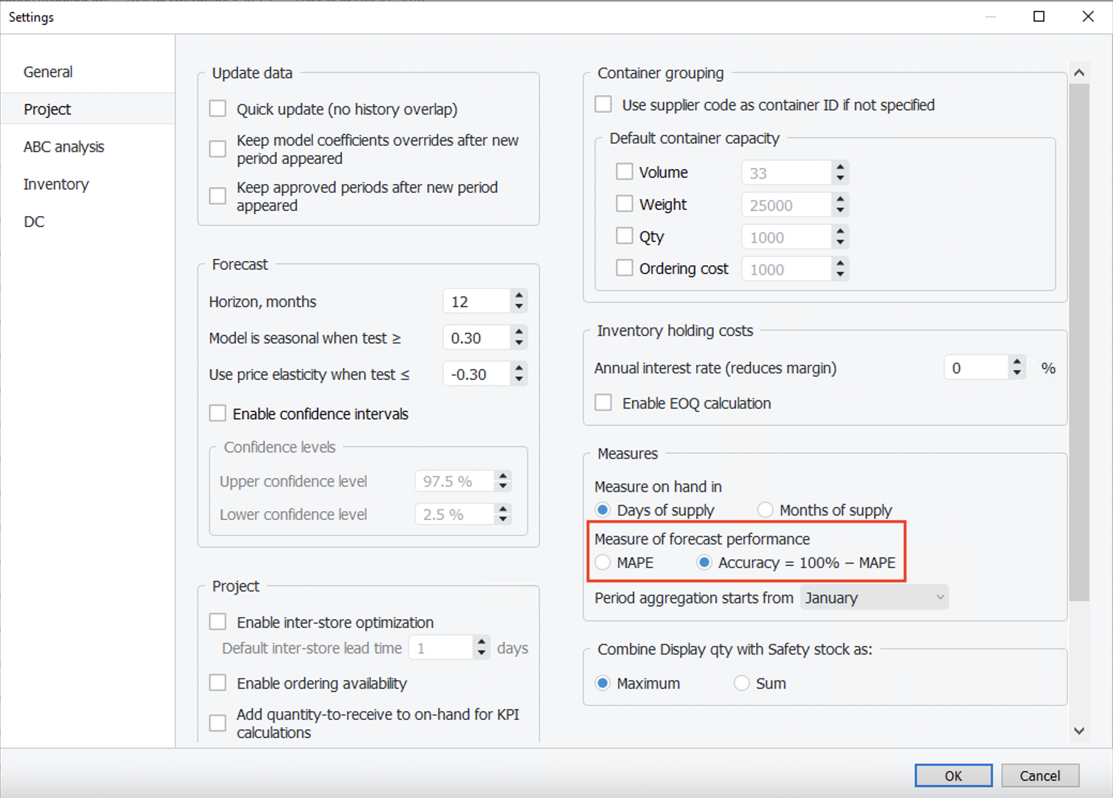
Now, the report shows the percentage accuracy of the forecasts for each period in the Percentage accuracy section and the average accuracy across the available evaluations in the last column (see figure below).
The Overall accuracy of the toolbar equals to 100% - Overall MAPE.
Tracedump:
newBaseSize: 16pt
newBaseSizeInPt: 16

