6.6. Exporting Purchase Plan
To plan supply (or manufacturing), your supplier needs to know a strategic plan containing the orders you intend to send him in the future. Streamline automatically calculates such the plan based on the forecasts and replenishment parameters. This plan can be easily exported to Excel.
Streamline shows the plan in the Purchase plan section of the inventory report. By default, this section is hidden. To display it:
- Go to the Inventory planning tab.
- Click the Settings button.
- Check the Show entire purchase plan option (see figures below).
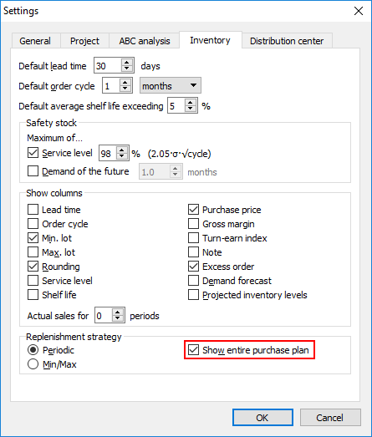
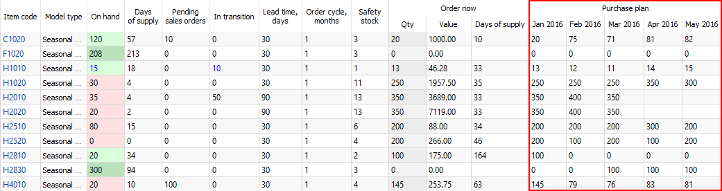
To export the plan to Excel, do the following:
- Go to the Inventory planning tab.
- Click the Export report button in the tab toolbar (see figure below).
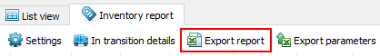
Streamline automatically creates an Excel file containing the exported report and opens it in Excel (see figure below).
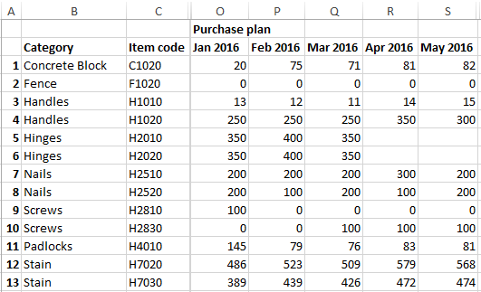

Next: Two-echelon Plannig
Download PDF
Tracedump:
newBaseSize: 16pt
newBaseSizeInPt: 16

